Mastering Q1/Q2 Manuscript Formatting: Common Pitfalls and How to Avoid Rejection
A practical manuscript formatting guide for researchers targeting Q1 and Q2 journals
You can spend two years on a study and lose two weeks to a formatting error. At Q1 and Q2 journals, where editors screen a large number of submissions, manuscript formatting is often the first test your paper faces. A messy file can trigger a desk rejection before anyone reads your results. This guide explains the most common formatting pitfalls and how to avoid them, so your paper is judged on its science.
Q1 and Q2 describe journal quartiles. A quartile is the rank band a journal holds within its subject category, based on indicators such as SCImago's SJR [1] or Clarivate's Journal Citation Reports [2] (Fig. 1). Q1 is the top quarter and Q2 the next quarter. The rules are the ones each journal publishes in its Guide for Authors [3]. What changes is the margin for error: strong journals usually receive many submissions, so careless files lose out more easily.
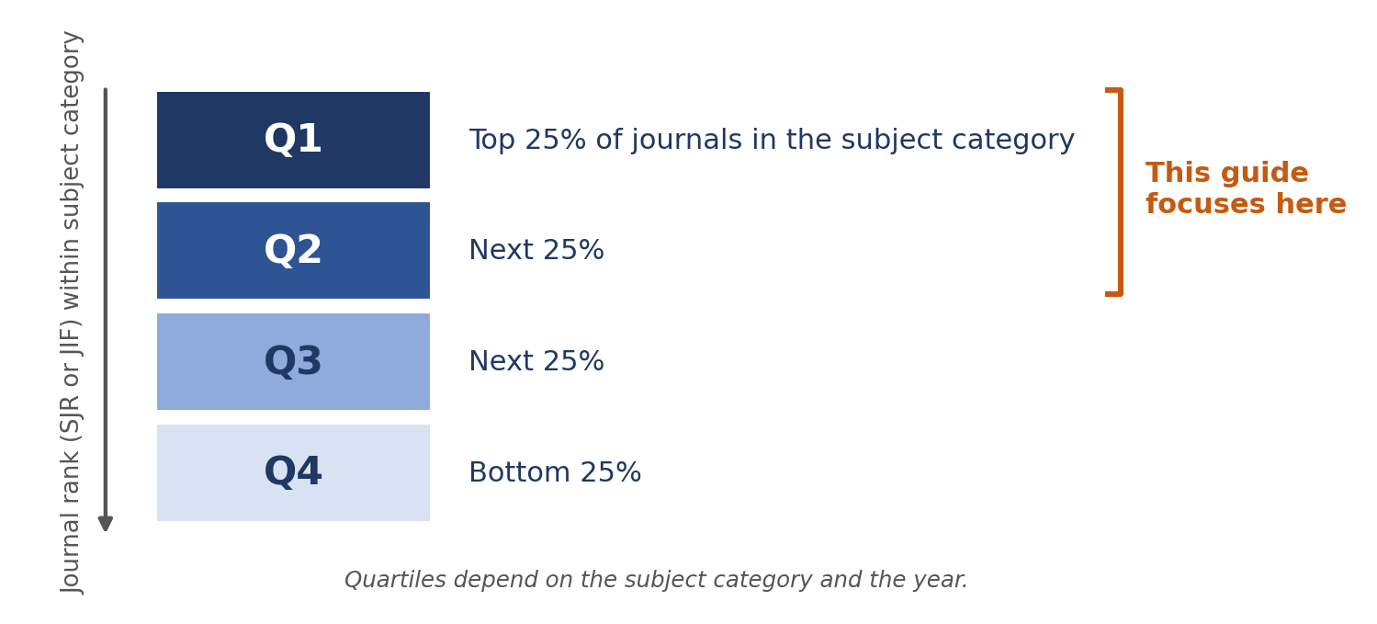
Fig. 1. Journal quartiles: Q1 and Q2 are the top half of journals in a subject category.

Why Manuscript Formatting Matters for Q1 and Q2 Journals
- A technical or editorial check often comes first. Files that break the rules can be returned before review.
- Editors form a quick impression. A clean first page signals that the authors are careful.
- Reviewers are busy volunteers. A paper that is easy to read earns more goodwill.
- Production teams need complete files and statements. Gaps slow down acceptance.
Formatting will not rescue weak science, but poor formatting can hide strong science. Remember also that a submission is more than one file. It is a package (Fig. 2), and every part must be ready.
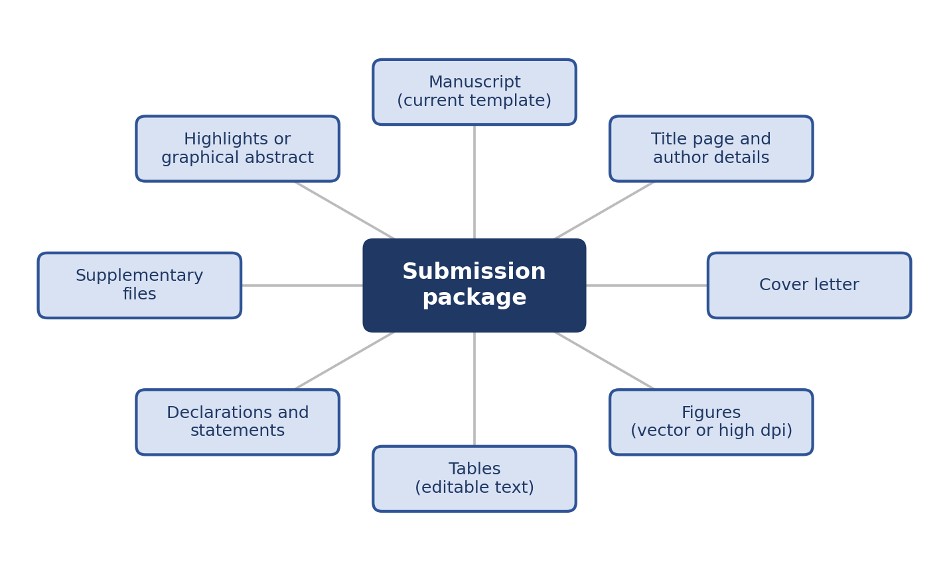
Fig. 2. A journal submission is a package, not a single file.

The Nine Most Common Manuscript Formatting Pitfalls
Fig. 3 ranks the pitfalls by how often they appear and how much damage they do. It is my own qualitative judgment, not a measured statistic. Start with the top-right corner.
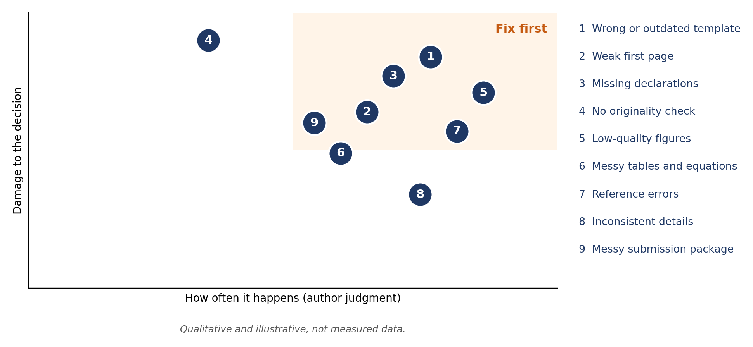
Fig. 3. Formatting pitfalls by frequency and damage (qualitative, illustrative).

Pitfall 1: Using the Wrong or Outdated Template
Templates change. Journals update them, and IEEE conferences replace theirs every year [4]. An old template is a quick way to look careless.
- Download the template from the current Guide for Authors or call for papers, never from an old paper.
- Write inside the template from day one. Converting later breaks equations, figures, and references.
- Do not change margins, fonts, or spacing to meet the page limit. Cut text instead.
- Read the whole guide, including word limits, article types, and anonymization rules.
Colleague tip Copy the journal's requirements into a one-page checklist before you start writing. You will use it again at the end.

Pitfall 2: A Weak First Page
The title, abstract, and keywords are what editors read first (Fig. 4).
- Keep the title specific and short, roughly 10 to 15 words, without unclear abbreviations.
- Keep the abstract within the word limit as a single paragraph. For IEEE papers, leave out citations, equations, and undefined abbreviations [5].
- Choose four to six keywords that add information. Do not just repeat the title.
- Check every author name, affiliation, and the corresponding author's details.
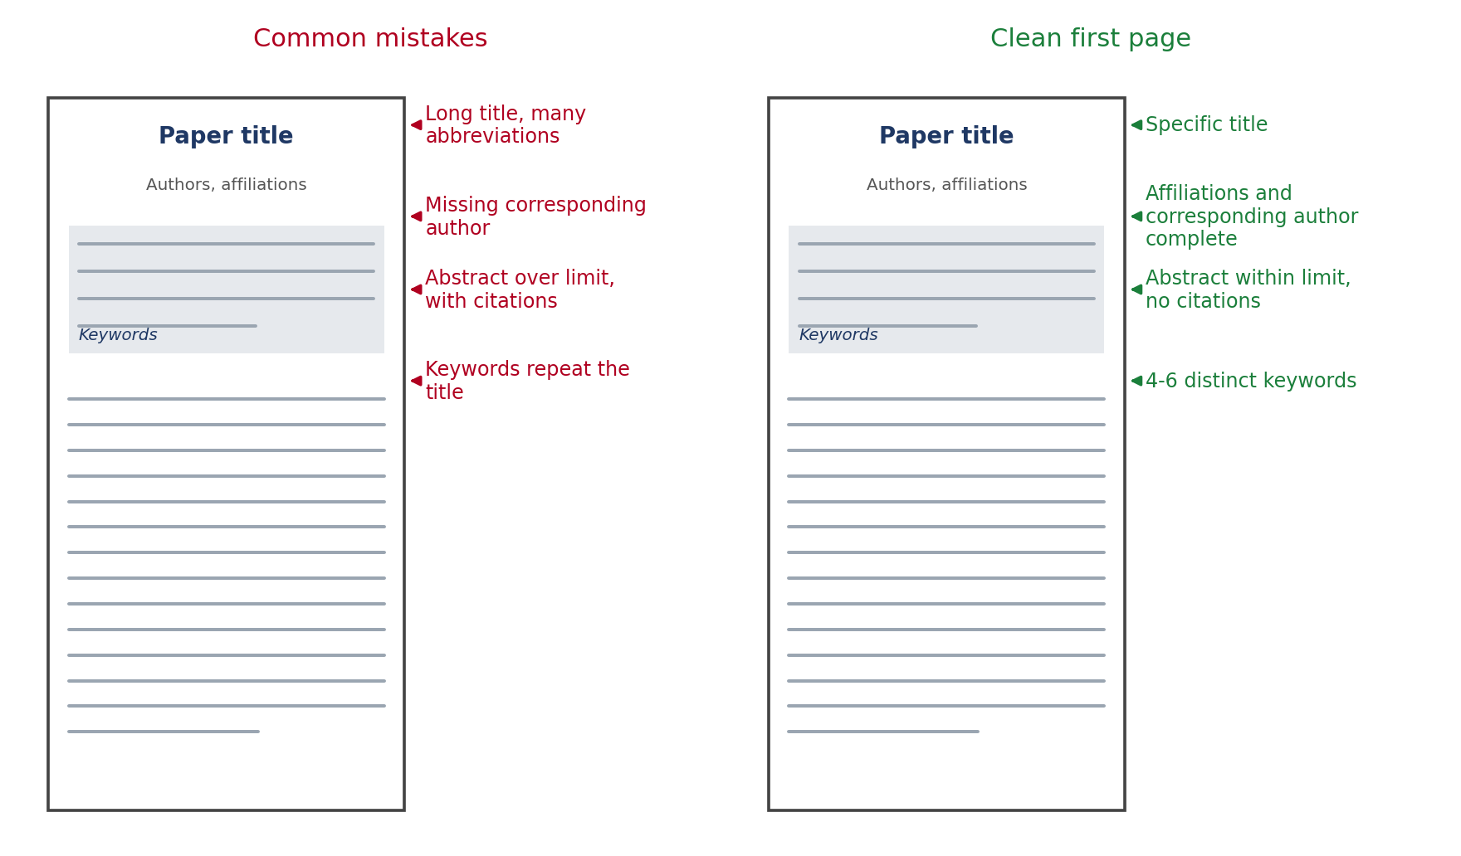
Fig. 4. First-page mistakes that editors notice, and the clean version.

Pitfall 3: Missing Declarations and Statements
Q1 and Q2 journals usually require a set of statements. Forgetting one is a common reason for an administrative return.
- Author contributions, ideally in the CRediT format [6].
- Competing interests, funding sources, and acknowledgments.
- Data availability, and ethics approval where it applies.
- Any generative AI disclosure the journal requires.
Agree on authorship early. Everyone listed should have contributed, and nobody who contributed should be missing, which matches the core practices of the Committee on Publication Ethics [7].

Pitfall 4: Skipping the Originality Check
Overlap with your own thesis, preprint, or conference paper is a classic trap. Editors run similarity checks, so you should run one first [8]. Rewrite overlapping passages, cite the earlier work, and explain any legitimate overlap in the cover letter. A journal extension of a conference paper should contain clearly new material.

Pitfall 5: Low-Quality Figures
Blurry or oversized figures are the easiest formatting problem to spot. Export plots and diagrams as vector PDF or EPS, and use TIFF or PNG for photos (Fig. 5). Elsevier commonly asks for 1000 dpi for line art, 300 dpi for halftone, and 500 dpi for combination images [9]. IEEE commonly asks for 600 dpi for line art and 300 dpi for color and grayscale images. Check your journal, because requirements vary.
- Size each figure at its final column width and keep text at 7 to 9 pt.
- Make figures readable in grayscale, and avoid red-green pairs for color-blind readers [10].
- Put captions below figures, and cite every figure in the text.
- Never submit screenshots of plots, and never upscale a low-resolution image.
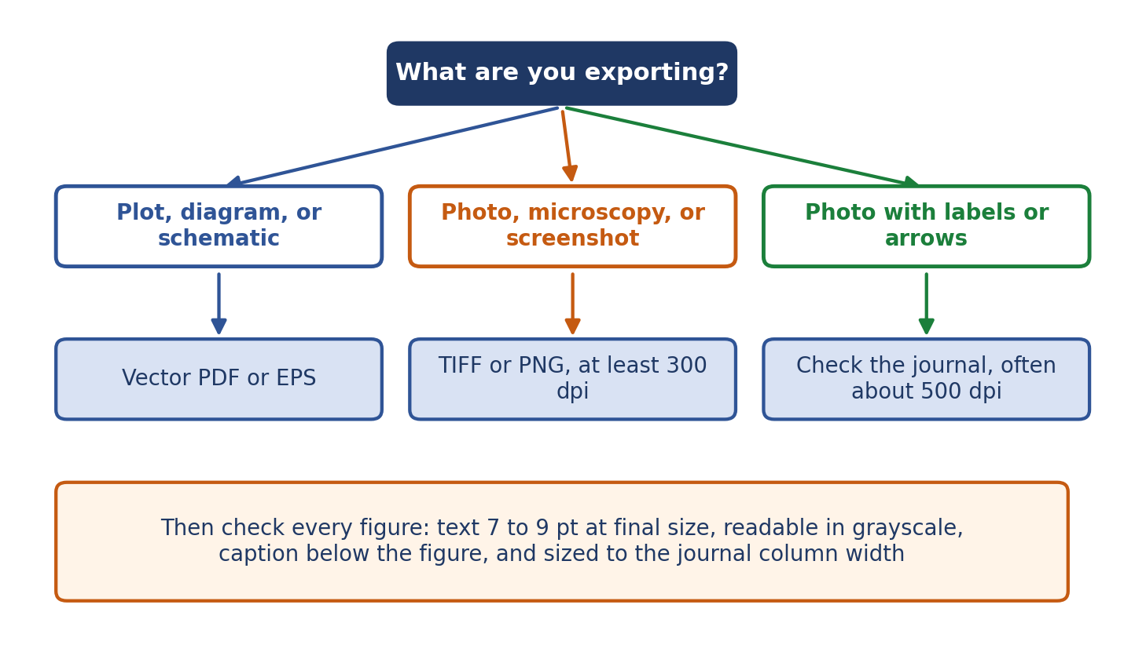
Fig. 5. A quick decision path for exporting figures.

Pitfall 6: Messy Tables and Equations
- Keep tables as editable text, never images, with captions above.
- Put units in column headers and use consistent decimal places.
- Number and cross-reference equations with labels, and punctuate them as part of the sentence.
- Define every symbol, and keep notation consistent across the paper.

Pitfall 7: Reference Chaos
Mixed citation styles look careless (Fig. 6). Match the journal's style, whether numbered or author-year, and let a reference manager or BibTeX do the formatting.
- Check every in-text citation against the list, and every entry against a citation.
- Add DOIs, complete page ranges, and consistent journal names.
- Search the compiled PDF for [?] before you submit.
- Include recent work and limit self-citation to what is relevant.
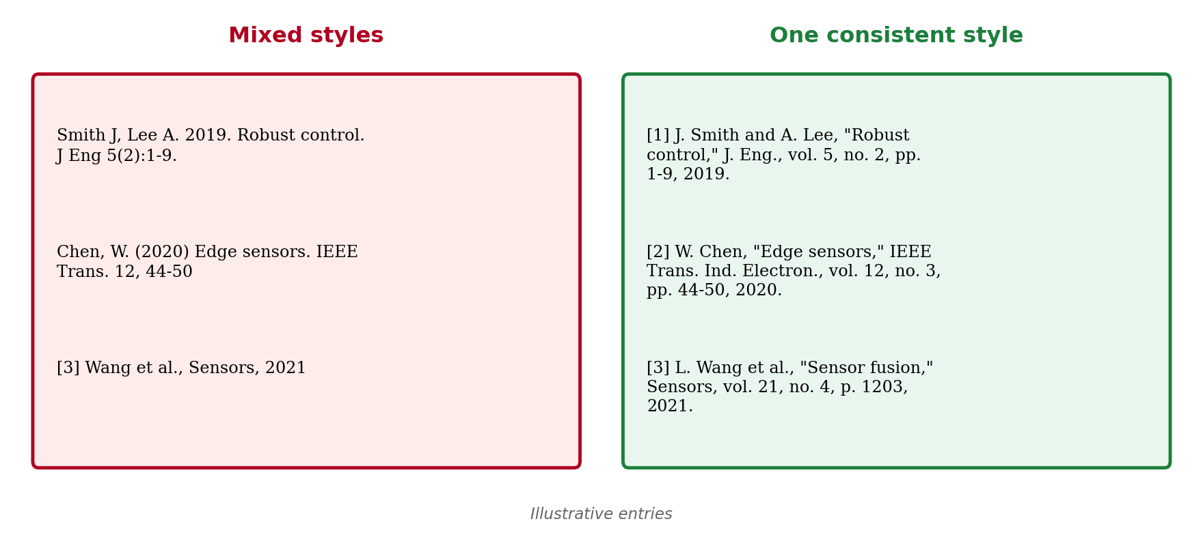
Fig. 6. Mixed reference styles versus one consistent style.

Pitfall 8: Inconsistent Details
Small inconsistencies add up to a sloppy impression. Do one dedicated consistency pass.
- Headings, numbering, and capitalization follow one pattern.
- Abbreviations are defined at first use, in the abstract and again in the text.
- Units follow SI conventions, with spaces between numbers and units.
- Spelling is consistent, either US or UK English, and figure and table references match their numbers.

Pitfall 9: A Messy Submission Package
- Name files clearly, such as Manuscript, Title_Page, Figure_1, and Supplementary_1.
- For double-blind review, remove names, self-identifying acknowledgments, and metadata.
- Write a short cover letter that states the contribution, why this journal fits, and that the work is not under review elsewhere.
- Prepare highlights, a graphical abstract, and source files if the journal asks for them.
- Do a dry run in the submission system and read the PDF it generates.
Colleague tip The system-generated PDF often reveals broken figures or missing fonts that your own PDF hides.

Your Two-Week Pre-Submission Timeline
Spread the work out instead of doing everything the night before (Fig. 7). Each stage has one job, and that keeps mistakes from piling up.
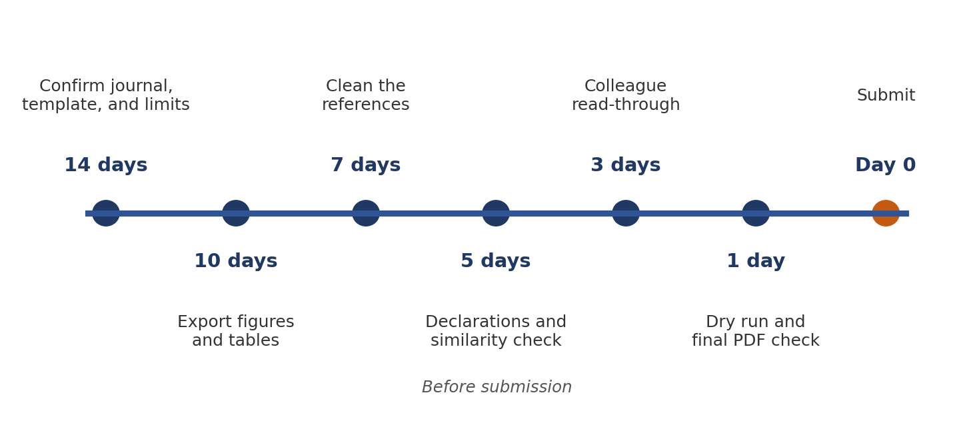
Fig. 7. A two-week schedule for a calm, error-free submission.

Final Manuscript Formatting Checklist
- The current template and Guide for Authors are followed, and the page and word limits are met.
- Title, abstract, keywords, and author details are correct and complete.
- All declarations and statements are included.
- A similarity check is done, and any overlap is explained.
- Figures meet the dpi and size rules, and tables are editable text.
- Equations are numbered and punctuated, and notation is consistent.
- References use one style and the compiled PDF has no [?].
- File names are clear, the cover letter is ready, and the dry run is done.

What to Do If Formatting Triggers a Return
A technical return is not a rejection. The journal is asking you to fix specific items. Read the list carefully, correct every point, and resubmit promptly. Then add the lesson to your own checklist so the same mistake never costs you time again.
Good manuscript formatting is a habit, not a talent. Follow the template, check the details, and keep your files clean, and your Q1 or Q2 submission gets the fair read it deserves.

References
[1] SCImago, "SJR: SCImago Journal & Country Rank," scimagojr.com.
[2] Clarivate, "Journal Citation Reports," clarivate.com.
[3] Elsevier, "Guide for Authors," available on each journal's homepage at sciencedirect.com.
[4] IEEE Author Center, "Templates for IEEE journal and conference articles," ieee.org.
[5] IEEE, "IEEE Editorial Style Manual for Authors," IEEE Periodicals.
[6] A. Brand, L. Allen, M. Altman, M. Hlava, and J. Scott, "Beyond authorship: Attribution, contribution, collaboration, and credit," Learned Publishing, vol. 28, no. 2, pp. 151-155, 2015.
[7] Committee on Publication Ethics (COPE), "Core Practices," publicationethics.org.
[8] Crossref, "Similarity Check," crossref.org.
[9] Elsevier, "Artwork and media instructions," Elsevier Author Resources.
[10] B. Wong, "Points of view: Color blindness," Nature Methods, vol. 8, no. 6, p. 441, 2011.

SEO Details for Your Website (remove before publishing)
Your keyword list was not included in the request, so these keywords were chosen for this topic. Send your own list and they can be swapped in.
Field | Suggested value
Focus keyword | manuscript formatting
Secondary keywords | Q1 journal submission, Q2 journals, avoid manuscript rejection, desk rejection, journal submission checklist, Elsevier manuscript template, IEEE paper format, research paper formatting guidelines, technical check, academic publishing tips
SEO title (under 60 characters) | Q1/Q2 Manuscript Formatting: Avoid Journal Rejection
Meta description (under 160 characters) | Learn the common manuscript formatting mistakes that cause rejection at Q1 and Q2 journals, and use our checklist to submit with confidence.
URL slug | q1-q2-manuscript-formatting-avoid-rejection
Suggested tags | manuscript formatting, journal submission, Q1 journals, Q2 journals, research publishing
Image alt text | Use each figure caption as its alt text, for example: Journal quartiles Q1 to Q4 within a subject category.

